Efficient Personal Protection Equipment Detection Unsing YOLOV3 For Construction And Production Sites

Vinayak K Shiva B Chiranjeevi C L Karthik D G

Dept of Artificial Intelligence & Dept of Artificial Intelligence & Dept of Artificial Intelligence & Dept of Artificial Intelligence &

Machine Learning Machine Learning Machine Learning Machine Learning

*Global Academy of Technology Global Academy of Technology Global Academy of Technology Global Academy of Technology*

Bangalore, Karnataka, India Bangalore, Karnataka, India Bangalore, Karnataka, India Bangalore, Karnataka, India

[vinaykattimani2@gmail.com](mailto:vinaykattimani2@gmail.com) [bagewadishiva2001@gmail.com](mailto:bagewadishiva2001@gmail.com) [Chiranjeevi625502@gmail.com](mailto:Chiranjeevi625502@gmail.com) [karthikdg444@gmail.com](mailto:karthikdg444@gmail.com)

Chethan S

Dept of Artificial Intelligence &

Machine Learning

*Global Academy of Technology*

Bangalore, Karnataka, India

[Chethans2002@gmail.com](mailto:Chethans2002@gmail.com)

**Abstract-** **In various occupational settings, ensuring the proper utilization of Personal Protection Equipment (PPE) is crucial for maintaining safety standards and minimizing risks to individuals. This study proposes a solution leveraging YOLOv8, a state-of-the-art object detection algorithm, for the automated detection of PPE items such as helmets, goggles, vests, and gloves. By employing a deep learning framework, the model is trained on annotated datasets to accurately identify and localize PPE within images or video streams in real-time. The proposed system offers a robust and efficient means of monitoring PPE compliance, thereby enhancing workplace safety protocols and facilitating proactive interventions to prevent accidents and injuries. Additionally, the versatility of the YOLOv8 architecture ensures scalability and adaptability across diverse environments and industries, making it a promising tool for enhancing occupational safety practices.**

**Keywords-PPE detection, YLOv8**

1. INTRODUCTION

In various occupational settings, ensuring the proper utilization of Personal Protection Equipment (PPE) is crucial for maintaining safety standards and minimizing risks to individuals. This study proposes a solution leveraging YOLOv8, a state-of-the-art object detection algorithm, for the automated detection of PPE items such as helmets, goggles, vests, and gloves. By employing a deep learning framework, the model is trained on annotated datasets to accurately identify and localize PPE within images or video streams in real-time. The proposed system offers a robust and efficient means of monitoring PPE compliance, thereby enhancing workplace safety protocols and facilitating proactive interventions to prevent accidents and injuries. Additionally, the versatility of the YOLOv8 architecture ensures scalability and adaptability across diverse environments and industries, making it a promising tool for enhancing occupational safety practices.

This paper proposes a vision-based approach to automatically identify the proper use of PPE in response to the limitations of the safety monitoring systems at the decommissioning sites. The current goal of this work is to detect the hard hats and full-face masks in each image captured by surveillance camera and to identify whether the individuals on the decommissioning sites are wearing PPE properly. This paper will describe how an image of an individual’s posture is characterized using Open Pose to extract a body’s main points. Then, the location of a hard hat and full-face mask is determined using the YOLOv3 model. Finally, the geometric relationship between the PPE and the body are analysed to determine whether the PPE is used appropriately

1. LITERATURE SURVEY

To address personal protection equipment Smit. J. developed a Time Object Detection for Personal Protective Equipment Monitoring in Industrial Environments [1] that make use of YOLOv3 for monitoring PPE compliance in industrial environments. The studies for accurately detecting PPE items Such as helmet, vest jacket and googles.

To maximize the efficiency of model Chen, X., Li, Z. did a survey named Enhancing Workplace Safety through Deep Learning-Based PPE Detection [2]. This survey provides an overview of recent advancements in PPE detection using deep learning techniques, including YOLOv8. Real-time examples from various industries, such as manufacturing, construction, and healthcare, are discussed to illustrate the practical implications of deploying such systems. The survey highlights the potential of YOLOv8-based solutions in mitigating safety risks and fostering a culture of compliance with PPE regulations.

The case study named Deep Learning-Based PPE Detection for Construction Safety [3]. This case study is done by Zhang, L., and This study investigates the application of YOLOv8 for PPE detection in construction sites. Through a case study involving real-time monitoring of workers, the authors demonstrate the efficacy of the proposed system in identifying PPE non-compliance instances promptly. The real-time examples illustrate how the integration of deep learning technologies can significantly improve safety practices in high-risk work environments.

Author Wang, J., In his International Conference on Computer vision he experimented on YOLOv8-Based PPE Detection System for COVID-19 Workplace Safety [4]. And presents a YOLOv8-based PPE detection system tailored for ensuring COVID-19 workplace safety. Real-time examples from office environments and healthcare facilities demonstrate the system's capability to detect face masks, gloves, and other protective gear essential for preventing virus transmission. The study underscores the importance of adopting automated PPE monitoring solutions in response to evolving public health challenges.

Integration of IoT and YOLOv8 for Real-Time PPE Monitoring in Smart Factories [5]. The Journal on Internet of things done by Kim, S., says that integration of YOLOv8 with Internet of Things (IoT) devices for real-time PPE monitoring in smart factory environments. The authors present a case study demonstrating how sensor data combined with deep learning-based object detection enables proactive safety measures. Real-time examples showcase the system's ability to detect PPE violations and trigger alerts for immediate intervention, contributing to a safer working environment.

Real-Time PPE Detection System for Firefighters Using YOLOv8 [6]. Author Garcia, M., presents that real-time PPE detection system specifically designed for firefighters. By leveraging YOLOv8, the system can accurately detect vital protective equipment such as helmets, breathing apparatus, and thermal suits in dynamic and challenging environments. Real-time examples demonstrate how the integration of such technology enhances situational awareness and safety for firefighting personnel.

Liu, G., presents Automated PPE Compliance Monitoring Using YOLOv8 in Mining Operations [7]. To summarizing research focuses on the application of YOLOv8 for automated PPE compliance monitoring in mining operations. The study showcases real-time examples of the system deployed in underground and surface mining sites, highlighting its effectiveness in identifying instances of PPE non-compliance among workers. The findings underscore the potential of deep learning technologies to mitigate safety risks in the mining industry.

YOLOv8-Based PPE Detection System for Occupational Health Surveillance in Healthcare Settings [8]. Wang, Q., says that YOLOv8-based PPE detection system tailored for occupational health surveillance in healthcare settings. Real-time examples from hospitals and clinics demonstrate the system's capability to detect PPE items such as masks, gloves, and gowns worn by medical personnel. The study emphasizes the importance of automating PPE monitoring to ensure infection control and patient safety.

Enhanced Worker Safety through YOLOv8-Based PPE Detection in Hazardous Chemical Environments [9]. Huang, K. says that the use of YOLOv8 for detecting PPE compliance in hazardous chemical environments. Real-time examples demonstrate the system's ability to identify protective gear such as chemical-resistant suits, goggles, and respirators worn by workers. The study highlights how automated PPE detection can minimize exposure risks and improve safety protocols in industries handling hazardous materials.

Intelligent Safety Helmet Detection System Using YOLOv8 in Construction Sites [10]. This study says that Real-time examples demonstrate the system's capability to identify workers wearing safety helmets and detect instances of non-compliance. The research highlights the potential of deep learning technologies to enhance safety awareness and reduce accidents in the construction industry.

1. METHODOLOGY

There are different algorithms and models for real time object detection. Among them YOLOv8 model caught our eye. It produces great results in real time object detection and has state of the art results with our own Dataset that contains 889 images where each image contains peoples working in site wearing safety gadgets like helmets, gloves, Vest jacket etc.

A overview of YOLOv8,

The architecture of YOLOv8 builds upon the previous versions of YOLO algorithms. YOLOv8 utilizes convolutional neural network that can be divided into two main parts: the backbone and the head. A modified version of the CSPDarknet53 architecture forms the backbone of YOLOv8. This architecture consists of 53 convolutional layers and employs cross-stage partial connections to improve information flow between the different layers. The head of YOLOv8 consists of multiple convolutional layers followed by a series of fully connected layers.

These layers are responsible for predicting bounding boxes, objectless scores, and class probabilities for the objects detected in an image. One of the key features of YOLOv8 is the use of a self-attention mechanism in the head of the network. This mechanism allows the model to focus on different parts of the image and adjust the importance of different features based on their relevance to the task .Another important feature of YOLOv8 is its ability to perform the multi scale object detection The model utilizes a feature pyramid network to detect objects of different sizes and scales within an image. This feature pyramid network consists of multiple layers that detect objects at different scales, allowing the model to detect large and small objects within an image.

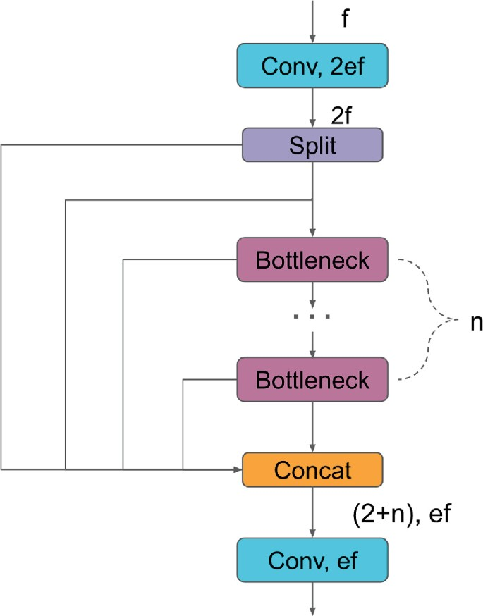

Fig. Architecture of YOLOv8

YOLO (You Only Look Once) is one of the most popular modules for real-time object detection and image segmentation, currently (end of 2023) considered as SOTA State-of-The-Art. YOLO is a conversional neural network that predicts bounding boxes and class probabilities of an image in a single evaluation.

Despite the undeniable efficiency of this tool, it is important to bear in mind that it was developed for a generalist context, aiming to serve the largest possible number of applications. However, for more specific cases requiring higher quality, speed, handling of non-standard images, among other scenarios, it is advisable to comprehend the architecture and, when possible, customize it to suit the task’s needs. To assist computer vision developers in exploring this further, this article is part 1 of a series that will delve into the architecture of the YOLOv8 algorithm.

The dataset in question is a valuable resource consisting of 889 images, each capturing a man engaged in construction work while adhering to comprehensive safety protocols. In each image, the individual is depicted wearing a complete set of personal protective equipment (PPE), including a helmet, hand gloves, and a vest jacket. These safety gears are essential for mitigating risks and ensuring the well-being of workers in hazardous construction environments. By providing a diverse collection of images featuring different activities and scenarios within a construction site, this dataset offers a realistic portrayal of the challenges and requirements associated with maintaining safety standards on the job.

Furthermore, the availability of such a dataset fosters collaboration and innovation within the research community, as it provides a standardized benchmark for evaluating the performance of different algorithms and methodologies. Researchers can compare the accuracy, speed, and robustness of their models against established baselines using this common dataset, leading to advancements in the state-of-the-art in PPE detection technology. Ultimately, the widespread adoption of accurate and reliable PPE detection systems based on this dataset has the potential to significantly enhance workplace safety practices in the construction industry, reducing the incidence of occupational accidents and injuries.

The significance of this dataset lies in its potential to facilitate the development and evaluation of object detection models specifically tailored for PPE compliance monitoring in the construction industry. With safety regulations mandating the use of appropriate protective gear, automating the detection of PPE usage becomes crucial for ensuring regulatory compliance and preventing accidents. By training machine learning algorithms on this dataset, researchers and practitioners can create robust models capable of accurately identifying and localizing safety equipment on workers in various contexts and conditions.

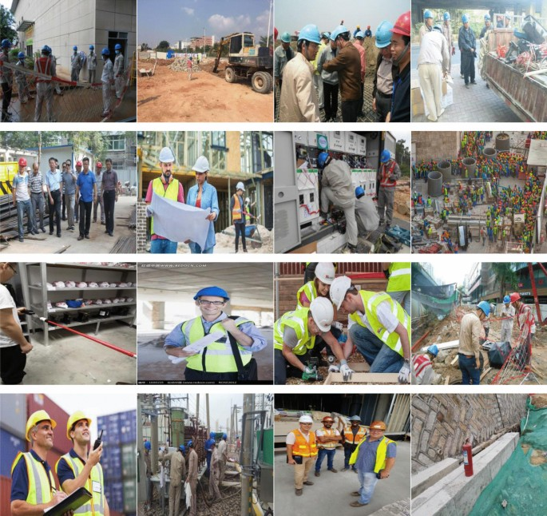

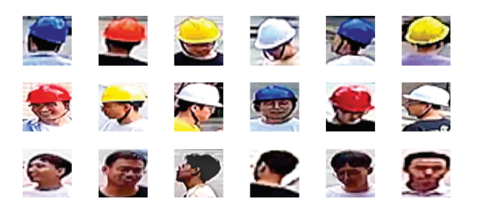

Fig. of Dataset

Moreover, the dataset's inclusion of a large number of images contributes to its richness and diversity, enabling comprehensive training and validation of detection algorithms. The variability in lighting conditions, worker postures, and background settings across the images reflects the real-world complexities encountered in construction sites, thereby enhancing the generalizability and reliability of the developed models. Additionally, the dataset's size allows for the exploration of different architectural approaches and training strategies, ultimately leading to the development of more effective and efficient PPE detection systems.

**Scenario**- Different wearable protections are often mandatory in industrial areas for workers to prevent serious injuries. Different body parts should be protected from injuries by adopting different PPEs. Firstly, the head should be protected from falling objects using hard hats. Moreover, in the head, we can also protect our ears and eyes from noisy machines and shards of glass by wearing hearing protection and using safety goggles, respectively. Second, we can improve the visibility of the chest area by wearing a safety vest or ensure stability by wearing a harness. Finally, body limps are vulnerable to burns or scratches, so workers should wear gloves and safety shoes.

In our work, we select one PPE for each body area to protect. For the upper area, we choose safety helmets, as they prevent critical injuries to the head. Second, we consider safety vests since they are widely used in many industrial contexts. Finally, for the arms and legs, we focus on recognizing gloves because workers often use their hands to interact with machines. The use-case considered in this paper is depicted in Figure 2. The workspace is a mixed space with low-risk and high-risk areas. In the latter, using PPEs, namely a helmet, a vest, and gloves, is

mandatory to protect the worker. The proposed system aims to analyse real-time images captured by a surveillance camera to detect workers not wearing PPEs. If a worker enters a high-risk area without protection, the system raises a visual or acoustic alarm to alert the worker. Specifically, an alarm will be issued for each PPE not worn. The system could also be connected to a controller that shuts down potentially dangerous machinery in the high-risk area, thus preventing injuries and improving safety.

**Model architecture-** Our system deploys a DNN to analyse the images on an edge computing node, i.e., an embedded system with limited computing capabilities. The edge node is physically close to the supervised environment: it receives the images via a Local Area Network (LAN) and analyses them without transmitting them to an external system or a cloud-based service, thus preserving workers’ privacy. In addition, since the system works in isolation and does not transmit any data, it is resilient to network outages and does not consume any bandwidth to offload the images to a cloud service.

In order to measure the position of the worker in the area, we adopted the Intel RealSense depth camera D435, a low-cost camera equipped with infrared stereo support that can measure the distance between the detected objects and the camera. he system can use this additional information to enable/disable the alarm according to the worker’s position, i.e., enable the alarm only when the worker is inside a high-risk area. It is important to notice that this is not a critical feature; the system can still work with cameras that do not provide distance estimation. In this case, however, alarms are triggered in the whole area without distinction between high and low-risk.

the architecture of our prototype created by exploiting commodity hardware is shown. The system comprises three main components: an embedded computing node, real-time image object detection is supported via the NCS2, which can support object detection via DL through hardware acceleration.

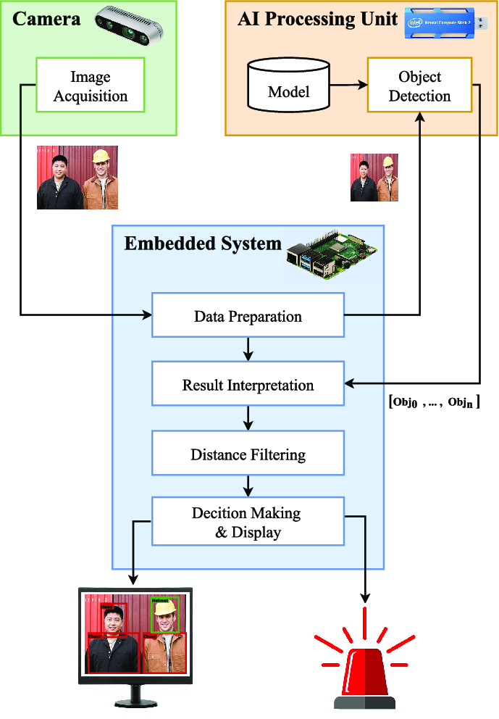

The image analysis process for PPE detection is carried out by exploiting a DNN for object detection. Image-based object detection is a computer vision task that consists of the following three sequential phases: (i) identify the presence of one or more objects on the image; (ii) locate the objects within the image boundaries; (iii) classify each object into one category, among the set of pre-defined categories. Specifically, the DNN initially identifies the regions of interest inside the image, considering all possible objects, and then labels each region to one of the possible classes of objects. A position is expressed through a bounding box, i.e., a rectangle surrounding the object and defining a specific region of interest. In other words, the object detection process consists of identifying the objects belonging to the categories of interest and associating each to a bounding box with the proper class label (i.e., the corresponding category).

As highlighted in Section II, CNNs are the most popular DNNs for object detection. These models allow to extract, at each level of the network, different image features characterized by an increasing level of specificity, i.e. from general to specific features. In this work, we consider a specific category of DNNs based on CNN, which adopts the one-stage regression-based detection approach: objects are detected by applying a regression process to predict simultaneously the target region and its category, i.e., the class. In order to select the most suitable model to deploy in our PPE detection system, we analysed the following state-of-the-art object detectors: ‘You Only Look Once version 4’ (YOLOv4) and its lightweight version (YOLOv4-Tiny), Single-Shot Detection (SSD), CenterNet, and Efficient.

When dealing with DNNs, especially for the object detection task in images, the higher the number of labelled training samples, the better the quality of the trained model. This aspect is due to the huge number of parameters to be optimized in such models. Thus, a large set of labelled images is needed to train a DNN from scratch. However, collecting and labelling images are very time-consuming tasks. Thus, researchers and practitioners usually exploit the transfer learning methodology [40] in which pre-trained models for approaching general tasks, such as a general object detection task, are selected and then fine-tuned. The fine-tuning process consists of adapting a pre-trained model to a more specific task, i.e., recognizing a specific set of PPEs in our case. For the pre-training stage of DNNs for object detection in images, a collection of datasets containing millions of images labelled with thousands of categories is currently available and recognized as effective by the specialized literature

A set of very accurate pre-trained DNNs, including the object detection task, is available in several machine learning and artificial intelligence software libraries and on verified online repositories. In this work, we compared the performance of five well known DNNs for object detection, namely the YOLOv8 network

1. . EXPERIMENTAL RESULTS

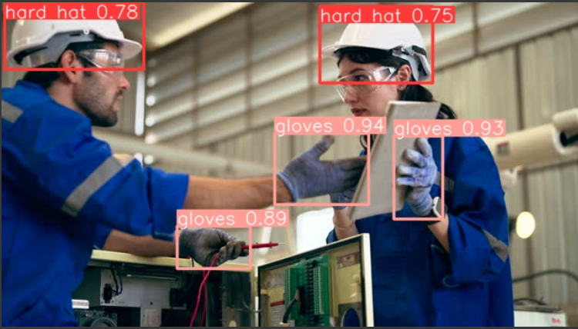

Model dividing input video into frames, each frames contains the ppe kits and now YOLOv8 job is to extract every feature from the frame and return result of object detection as there name as helmet gloves etc. if safety gears not detected in frame them output goes to the Arduino and returns loudly alarm alert.

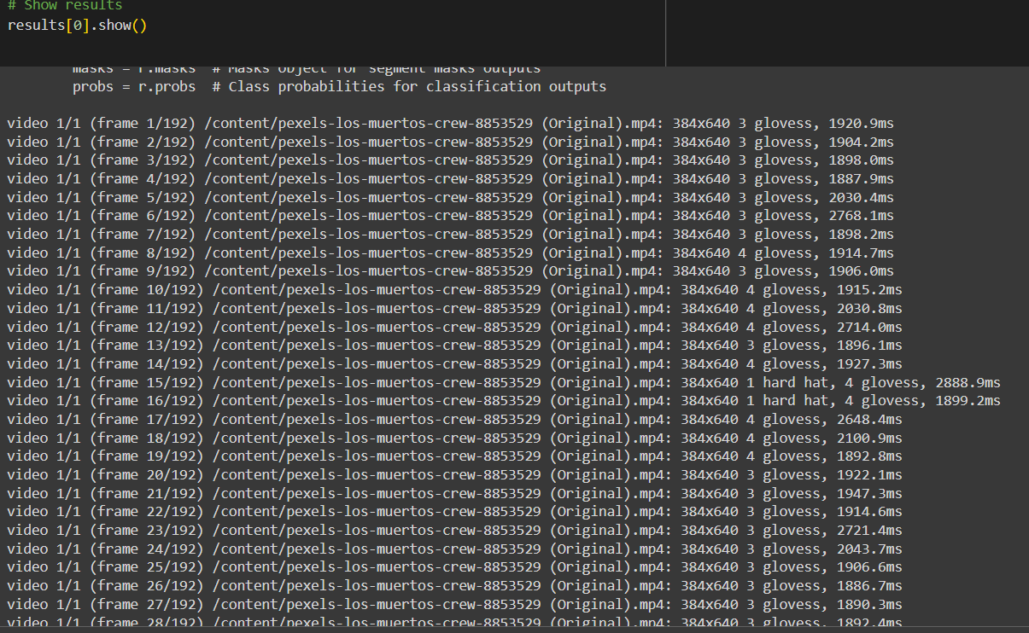

1. MOTIVATION

The experimental motivation for utilizing the dataset containing 889 images of individuals working in construction sites with full safety gear stems from the critical need to enhance workplace safety practices in the construction industry. Construction sites are inherently hazardous environments where workers face various risks and dangers, including falls, impact injuries, and exposure to harmful substances. Despite stringent safety regulations and guidelines mandating the use of personal protective equipment (PPE), ensuring compliance among workers remains a significant challenge.

The primary objective of conducting experiments with this dataset is to develop and evaluate automated systems for detecting PPE usage among construction workers accurately. By leveraging machine learning and computer vision techniques, researchers aim to create robust algorithms capable of identifying and localizing safety gear, such as helmets, hand gloves, and vest jackets, worn by individuals in construction site imagery. Such systems hold immense potential for streamlining safety inspections, monitoring PPE compliance in real-time, and facilitating proactive interventions to prevent accidents and injuries.

Moreover, the experimental motivation is furled by the limitations and shortcomings of existing manual methods for monitoring PPE compliance. Traditional approaches, such as manual inspections conducted by supervisors or safety officers, are labour-intensive, time-consuming, and prone to human error. By contrast, automated PPE detection systems offer the promise of improved efficiency, accuracy, and scalability, thereby enabling more effective safety management practices in construction workplaces.

Furthermore, the experimental motivation is driven by the potential societal impact of deploying accurate and reliable PPE detection technologies. Construction-related accidents and injuries not only pose a significant burden on affected individuals and their families but also incur substantial costs for employers and society at large. By developing automated systems that can swiftly identify instances of PPE non-compliance, researchers aim to mitigate these risks, reduce the incidence of accidents, and foster a safer working environment for construction workers.

In summary, the experimental motivation for leveraging the dataset revolves around addressing critical safety challenges in the construction industry, improving PPE compliance monitoring, and ultimately enhancing workplace safety practices to protect the well-being of workers and prevent occupational hazards.

1. CONCLUSION

In conclusion, the utilization of the dataset comprising 889 images depicting individuals wearing full safety gear while working in construction sites serves as a pivotal step towards addressing the pressing need for enhanced workplace safety practices in the construction industry. Through experimental endeavours aimed at developing and evaluating automated systems for PPE detection, researchers strive to overcome the limitations of traditional manual methods, improve efficiency, and reduce the incidence of occupational accidents and injuries. By leveraging machine learning and computer vision techniques, these efforts hold the promise of streamlining safety inspections, ensuring PPE compliance in real-time, and fostering a culture of safety awareness within construction workplaces. Ultimately, the deployment of accurate and reliable PPE detection technologies has the potential to make a significant societal impact by safeguarding the well-being of construction workers and minimizing the human and economic costs associated with workplace accidents.

1. REFERENCES

[1]OSHA, Commonly used statistics, https://www.osha.gov/oshstats/commonstats. html , Accessed date: 6 July 2019.

[2]OSHA, Worker safety series: construction, https://www.osha.gov/Publications/ OSHA3252/3252.html , Accessed date: 6 July 2019.

[3] Centers for Disease Control and Prevention, Traumatic brain injuries in construction, https://blogs.cdc.gov/niosh-science-blog/2016/03/21/constructiontbi/ , Accessed date: 6 July 2019.

[4] OSHA, Safety vest requirements to protect flaggers from traffic hazards during construction work, https://www.osha.gov/laws-regs/standardinterpretations/ 2002-03-11 , Accessed date: 6 July 2019.

[5] OSHA, Safety and health regulations for construction, https://www.osha.gov/lawsregs/regulations/standardnumber/1926/1926.28 , Accessed date: 6 July 2019

[6] F. Akbar-Khanzadeh, Factors contributing to discomfort or dissatisfaction as a result of wearing personal protective equipment, J. Hum. Ergol. 27 (1–2) (1998) 70–75.

[7] Q. Fang, H. Li, X. Luo, L. Ding, H. Luo, T.M. Rose, W. An, Detecting non-hardhat-use by a deep learning method from far-field surveillance videos, Autom. Constr. 85 (2018) 1–9, https://doi.org/10.1016/j.autcon.2017.09.018.

[8] X. Huang, J. Hinze, Analysis of construction worker fall accidents, J. Constr. Eng. Manag. 129 (3) (2003) 262–271, https://doi.org/10.1061/(asce)0733-9364(2003) 129:3(262).